SYNOPSIS OF COURSE PROJECT
TOPIC: Multilingual sign language interpreter

SR NO. | ROLL NO. | NAME OF STUDENT
1 | 17 | ATHARV MALI
2 | 18 | SHUBHAM MALI
3 | 20 | GITESH MANE
4 | 21 | PRATIK MASANI

GUIDE: PROF. PUJA CHOLKE

INTRODUCTION:
Sign language is the daily language of communication between deaf and dumb people. It is the most comfortable and natural way for deaf and dumb people to communicate, and it is also the primary tool for special education schools to teach and convey ideas . And for normal people it will be more difficult to understand signed language so to overcome this language barrier multilingual signed language detection application and conversion of that signed language into text and from that text to speech has been developed . so that it will be more beneficial for society .

OBJECTIVES:
- To make an easy to access application that can be used to easily interpret all the different sign languages which makes it easy to communicate with the specially abled.
- After the literature review we have analyzed that in the currently available models there are no multi language translators available but we plan to make a multi language translator using google APIs.
- For Example: when the sign language is interpreted it translates it and will be available to us in multiple languages according to our need.
LITERATURE SURVEY:
- A. Kumar, K. Thankachan and M. M. Dominic, "Sign language recognition," 2016 3rd International Conference on Recent Advances in Information Technology (RAIT), Dhanbad, India, 2016, pp. 422-428, doi: 10.1109/RAIT.2016.7507939.
A sign language recognition system that employs Hidden Markov Models (HMMs), Artificial Neural Networks (ANNs), and template matching. Using a skin color segmentation technique,
the system initially recognises hand forms and records hand movements in sign language films. It then extracts information like hand trajectory and hand orientation, which are fed into HMMs and ANNs for recognition.On two sign language datasets.
the system achieves recognition rates of 87.9% and 92.6%, respectively. The paper finds that a hybrid strategy combining HMMs, ANNs, and template matching can increase the accuracy and resilience of sign language recognition

- Huang, K. C., Kao, Y. T., & Wu, H. C. (2017). Evaluating the effectiveness of a mobile application for Chinese Sign Language recognition. Computers & Education, 109, 24-35.

The development of mobile applications for sign language interpreting is one field of study.

Mobile apps offer the ability to enable instant access to sign language interpretation for a variety of reasons such as education, communication, and information dissemination.
Huang, Kao, and Wu (2017) investigated the efficacy of a smartphone app called "SignHelper" for Chinese Sign Language interpretation. The application was proven to be helpful in providing accurate and quick sign language interpretation, according to the study .

- Sharma, S., Singh, S., & Dey, S. (2021). Sign language recognition using deep learning for Indian Sign Language. SN Computer Science, 2(4), 1-12.

Aside from mobile applications and augmented reality (AR), researchers have looked into the use of artificial intelligence (AI) in sign language interpretation.

Artificial intelligence (AI) can be used to recognise and interpret sign language gestures into text or spoken language. Sharma and colleagues (2021) created an AI-based sign language recognition system for Indian Sign Language in their study.

The study discovered that the technology recognised sign language motions with excellent accuracy

METHODOLOGY:
The proposed system works as a user-friendly android application using java.

It consists of two different applications for interpreting the sign language one is real time interpretation and the other is via capturing the image and then interpreting.

This application also provides us with different options for sign language interpretation as there are multiple sign languages depending on the region such as Indian Sign Language(ISL),American Sign Language (ASL) British, Australian and New Zealand Sign Language (BANZSL) etc.

In real time interpretation the application interprets the sign language frame by frame continuously and then interprets the selected sign language accordingly and these interpreted signs are arranged respectively in the order they are interpreted, and then these interpreted signs are converted from text to speech in order to give out a proper sentence.

The text to speech conversion also includes the conversion of language from English to Hindi, Marathi and several other languages spoken in India so as to provide good means of communication all around.

Flowchart :
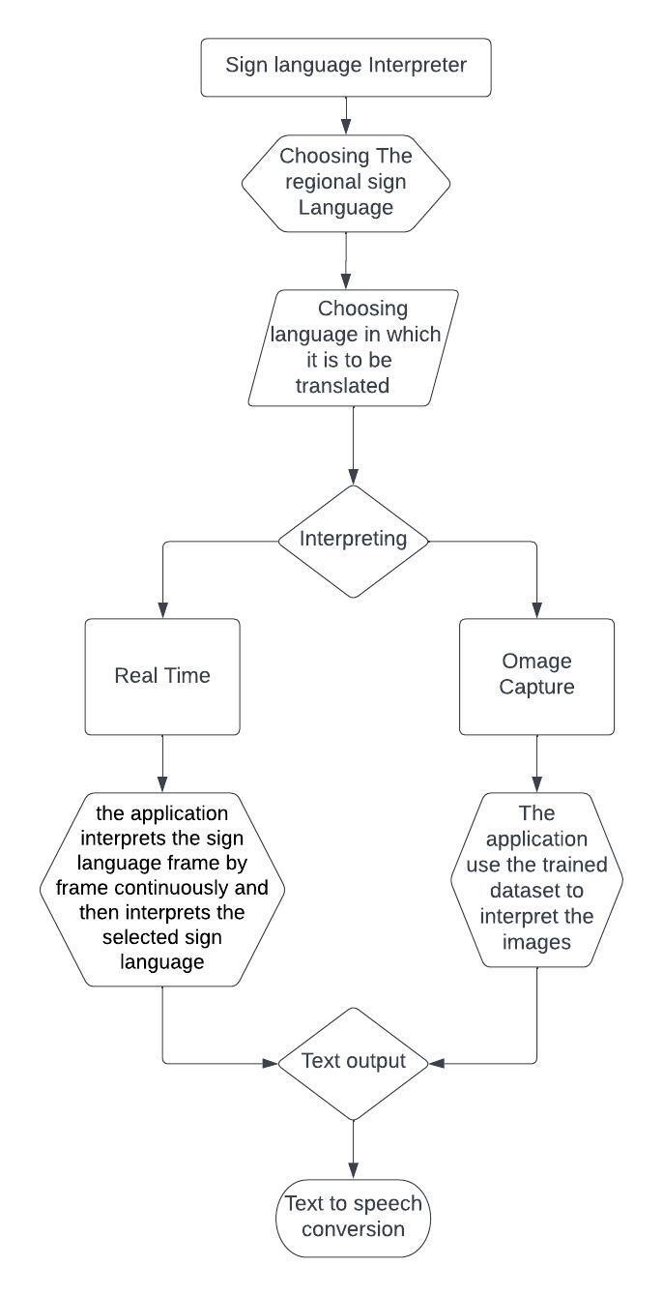

Conclusion :
From the above research we have inferred many things as well as proposed a system that provides all the amenities provided by the previous solution and more.

One of the very important inference that this research came upon was that the existing system for sign language interpretation doesn’t provide with different more than one sign language interpretation as there are different regional sign languages, also the existing solution doesn’t provide with text to speech conversion into desired language, both of the above mentioned problems are countered in this demonstration which makes is a very reliable solution for specially abled peoples .
Results :
